Name : Lokare Mahir Abdul Majeed

Roll no : 23AI34

Batch:02

Experiment No: 06

AIM: To study and implementation of Hebbian Learning Algorithm.

RESOURCE REQUIRED:

Google repository, Dataset, Jupyter Notebook

THEORY:

Hebbian Learning Rule, also known as Hebb Learning Rule, was proposed by Donald O Hebb. It is one of the first and also easiest learning rules in the neural network. It is used for pattern classification. It is a single layer neural network, i.e. it has one input layer and one output layer. The input layer can have many units, say n. The output layer only has one unit. Hebbian rule works by updating the weights between neurons in the neural network for each training sample.

Hebbian Learning Rule Algorithm :
- Set all weights to zero, wi = 0 for i=1 to n, and bias to zero.
- For each input vector, S(input vector) : t(target output pair), repeat steps 3-5.
- Set activations for input units with the input vector Xi = Si for i = 1 to n.
- Set the corresponding output value to the output neuron, i.e. y = t.
- Update weight and bias by applying Hebb rule for all i = 1 to n:
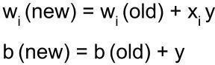

Implementing AND Gate :
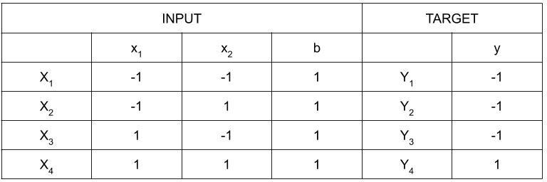

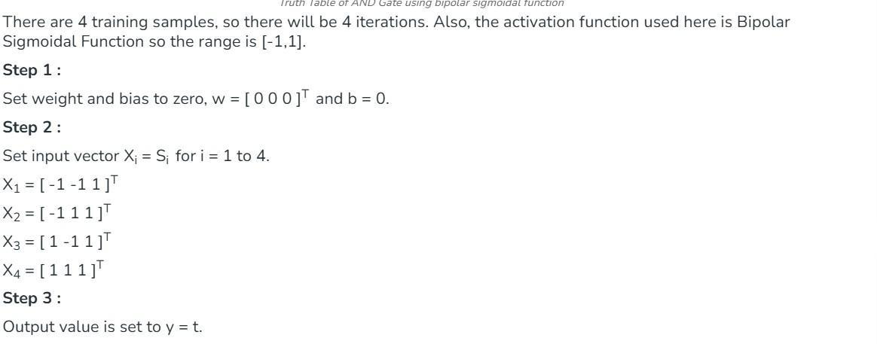
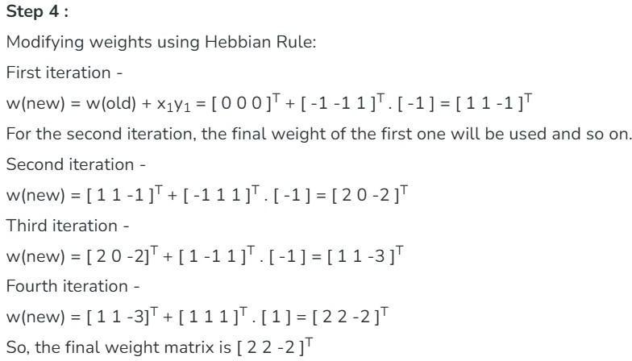
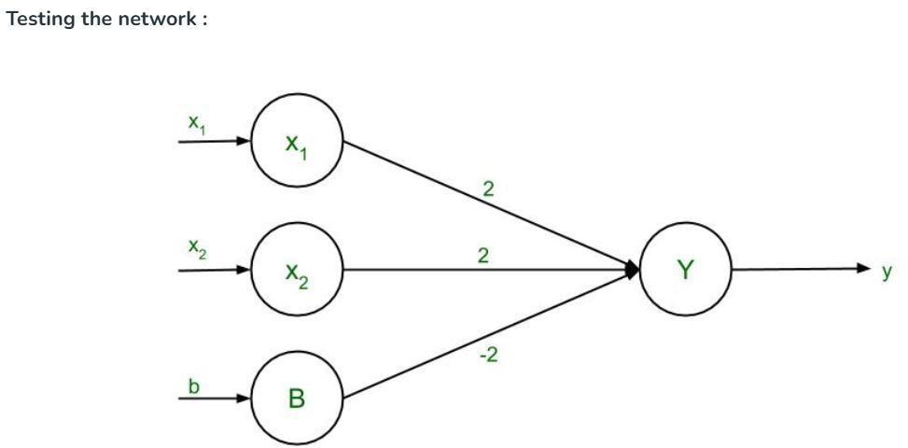

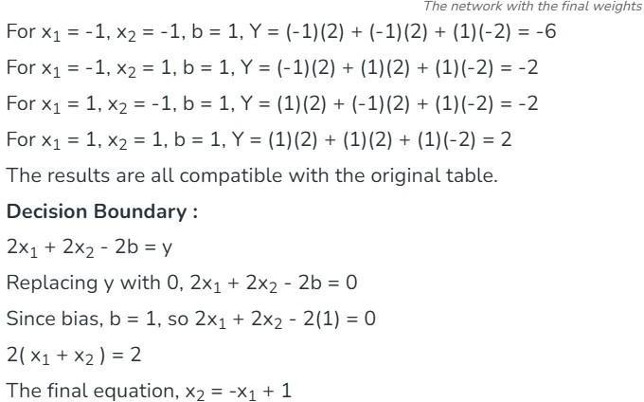
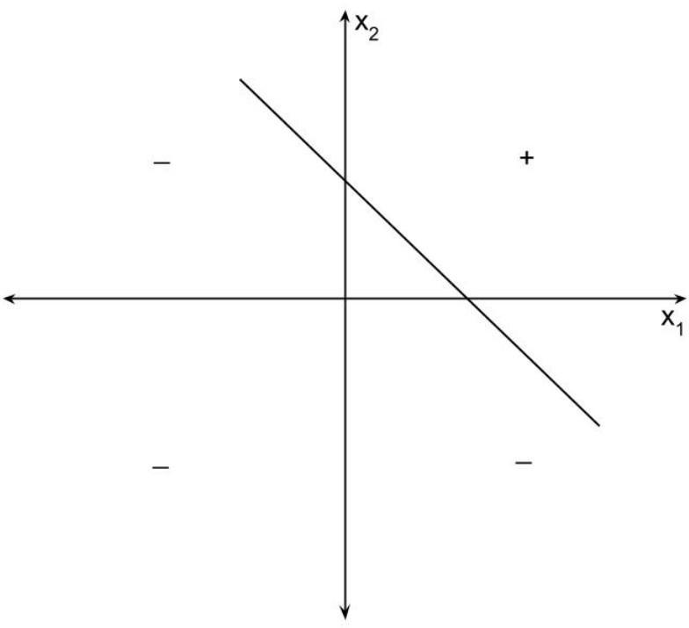
Application of Hebbian Learning
This simple Hebbian learning example can be applied to various fields, such as:
  - Pattern Recognition: The network can learn to recognize and recall simple binary patterns.
  - Associative Memory: Hebbian learning can be used to implement associative memory, where the network can recall outputs associated with given inputs.
  - Neural Computation: This example demonstrates fundamental neural computation principles inspired by biological brains.

IMPLEMENTATION:

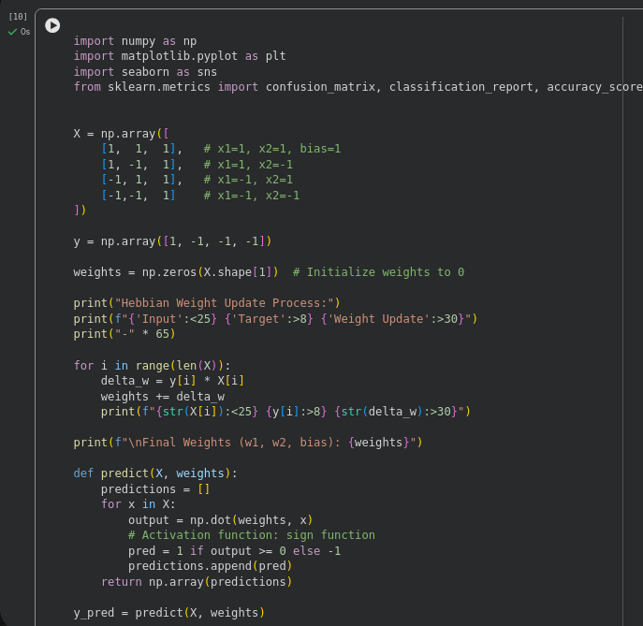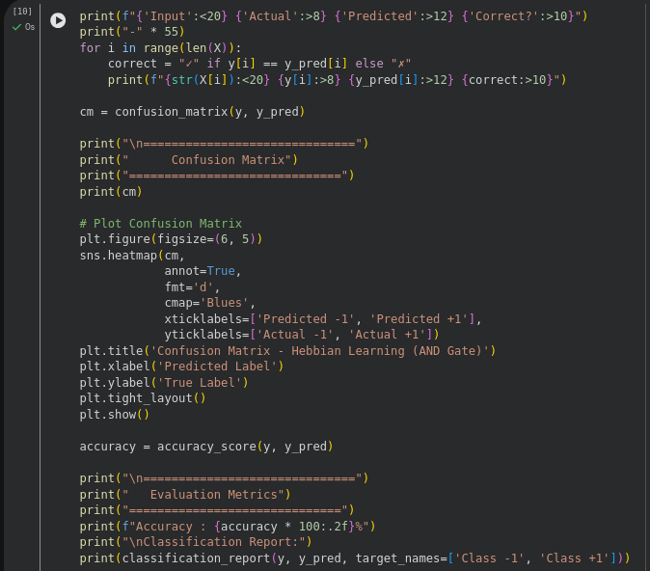

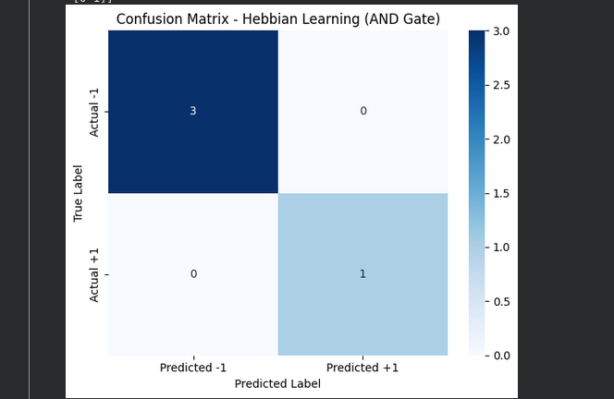

CONCLUSION:
Hebbian learning is a powerful and biologically inspired learning mechanism that can be applied to artificial neural networks. By understanding and implementing Hebbian learning, we can create networks that learn and adapt in a manner similar to how the human brain does.

